LAB EXPERIMENT

***Submitted By***

***A.Tejeswar Reddy (192111507)***

***In partial fulfilment for the completion of the course***

CSA1802 – HUMAN COMPUTER INTERACTION FOR COMMUNICATION



SIMATS SCHOOL OF ENGINEERING

SAVEETHA INSTITUTE OF MEDICAL AND TECHNICAL SCIENCES

TAMIL NADU

CHENNAI- 602105

JANUARY – 2025

**INDEX**

|  |  |  |  |
| --- | --- | --- | --- |
| **S.NO** | **EXPERIMENT NAMES** | **PAGE.NO** | **SIGN** |
| **1** | Describe the essential components and functionalities of a food recipe mobile app that allows users to search for recipes, upload their own recipes, access cooking tutorials, and engage with a cooking blog. | 1 |  |
| **2** | Design and describe the user interface and functionality of an online blanket selling application that offers weighted designer blankets aimed at improving sleep quality and overall well-being. Outline the steps a user would take to interact with the application, including the processes of logging in, registration, browsing and selecting products, applying discounts and coupons, and completing the product purchase. Provide a clear overview of how the app engages users and facilitates the purchasing process. | 2 |  |
| **3** | Design a mobile app concept named Expense Share that assists users in tracking and splitting expenses among friends. Outline the key features and functionalities of the app, including login, registration, expense calculator, Split-up messenger and Navigation. | 3 |  |
| **4** | Design and create the mobile app for “health and self-care”, including user  registration and login, health routine blogs, self-care blogs, self-care video tutorials, and subscription features. | 4 |  |
| **5** | Design the template with features and functionalities for an intelligent “job assisting app” that aims to expedite the process from job search to contract signing. Include details about user interactions such as login, registration, subscription, providing personal details, uploading a resume, and selecting a job. | 5 |  |
| **6** | Create the mobile app to assist users in finding and booking parking slots in unfamiliar areas. Include details about user registration and login, displaying the count of available parking slots, showing free parking slot information, allowing users to book slots, and generating parking-related bills. | 6 |  |
| **7** | Design and create the mobile app to facilitate “international hospitality services”, including user registration and login, displaying discounted and available stays, booking stays on specific dates, and generating bills. | 7 |  |
| **8** | Design a lab experiment to create a prototype for a food recipe mobile | 8 |  |

|  |  |  |  |
| --- | --- | --- | --- |
|  | app with the following features:   1. User authentication (login and registration). 2. Selection of preferred location and cuisine. 3. Display of recipe video tutorials. 4. User&#39;s ability to upload their own recipes. |  |  |
| **9** | Design and create the “chatting app” for a community of friends, including user registration and login, status updates, friend adding, group creation, video/audio calls, and individual/group chat capabilities. | 9 |  |
| **10** | Design the key features and functionalities of a movie ticket booking app, including user registration and login, movie selection, seat reservation, and online payment, that would be required for a lab exam question. | 10 |  |
| **11** | Create the “food ordering mobile app” that allows users to register, log in, select cuisine, place food orders, calculate discounts, make online payments, and track their orders in real-time using a live map. | 11 |  |
| **12** | Design the template with essential features and functionalities required for a “Cab Booking App” that facilitates user registration and login, pickup and drop location selection, discount calculation, online payment, and live map tracking. | 12 |  |
| **13** | Design the template with features and functionalities of a Grocery Ordering App that allows users to log in, register, view grocery options, place orders, make online payments, and track their orders in real-time, all while incorporating a live map tracking feature. | 13 |  |
| **14** | Design a news publication app that caters to users#39; preferences by offering features such as login, registration, news shorts, a display of various newspapers, online payment capabilities, and subscription options. | 14 |  |
| **15** | Create the news publication#39;s video surfing app, describe the essential features and functionalities required to be implemented, both for regular users and premium members, encompassing aspects such as user authentication, content discovery, contribution, and membership. | 15 |  |
| **16** | Design a Flight Ticket Booking App that allows users to search and book both local and international flights. The app should have the following features:   1. Login 2. Register 3. Pickup and Drop Location | 16 |  |

|  |  |  |  |
| --- | --- | --- | --- |
|  | 1. Flight Options 2. Booking Page 3. Ticket Generation |  |  |
| **17** | Develop a comprehensive Online Shopping App that allows users to seamlessly browse, select, and order products. The app should include the following features:   1. Login 2. Register 3. Product Display 4. Product Selection 5. Ordering Page 6. Bill Generation | 17 |  |
| **18** | Describe the template with features and functionalities for a Hostel Reservation App for online hotel booking, including user authentication, location selection, date of booking, hotel listings, and the booking and billing process. | 18 |  |
| **19** | Design a mobile application for online mobile recharge that allows users to perform  the following actions:   1. Log in or register to access the app. 2. View and select from various top-up and data plans. 3. Utilize a group top-up feature for multiple numbers. 4. Choose from different payment options and proceed to payment. 5. Implement a secure payment gateway for processing transactions. | 19 |  |
| **20** | Design a user-centric Online Music Surfing App that allows users to explore, create playlists, and download music. Include the following functionalities within your design: login, Register, Add to Playlist, Download, Subscription and Payment Gateway. | 20 |  |

**1. Food Recipe Mobile App**

This is a mobile application that enables users to search for recipes, upload their own recipes, access cooking tutorials, and engage with a cooking blog.

**AIM:**

To design a mobile application that allows users to explore, share, and learn about recipes efficiently.

**PROCEDURE:**

1. Install the required development tools.
2. Create a wireframe & UI design.
3. Develop user authentication and recipe management.
4. Implement search, filtering, and recommendation features.
5. Integrate cooking tutorials and blog section.
6. Optimize for different screen sizes and touch interactions.
7. Test, refine, and deploy the application.

**OUTPUT:**

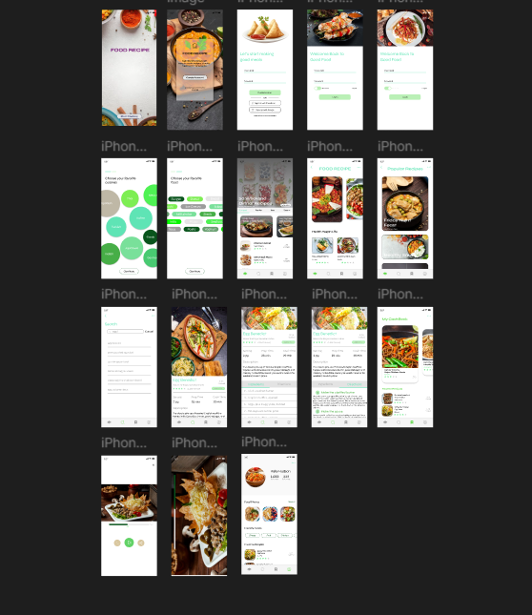

**RESULT:**

The Food Recipe Mobile App has been successfully developed, allowing users to explore and share cooking experiences seamlessly.

**2. Online Blanket Selling Application**  
 This is a mobile application that enables users to browse, select, and purchase weighted designer blankets aimed at improving sleep quality and overall well-being.

**AIM:**

To design an online shopping application that allows users to explore, purchase, and benefit from premium weighted blankets.

**PROCEDURE:**

1. Install the required development tools.
2. Design the user interface with intuitive navigation and product displays.
3. Implement user authentication for registration and login.
4. Develop product browsing, filtering, and selection features.
5. Integrate discount and coupon functionalities.
6. Implement a secure checkout and payment system.
7. Test, refine, and deploy the application.

**OUTPUT:**

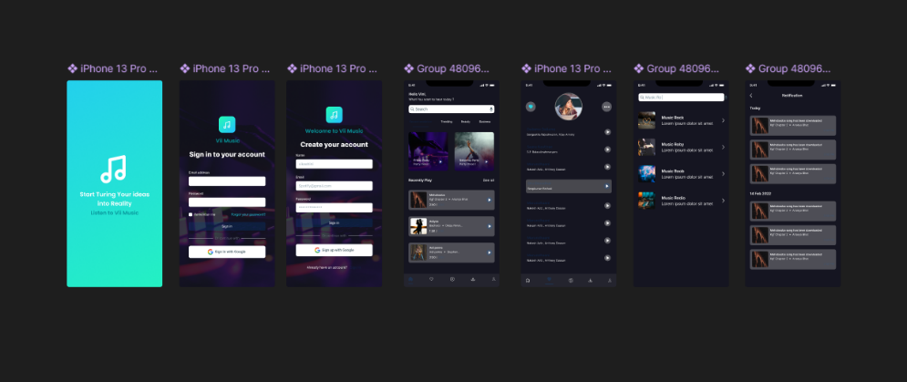

**RESULT:**

The Online Blanket Selling Application has been successfully developed, allowing users to browse, apply discounts, and complete purchases effortlessly**.**

**3. Expense Share Mobile App**  
 This is a mobile application that helps users track and split expenses among friends efficiently.

**AIM:**

To design a mobile application that enables users to manage shared expenses and payments seamlessly.

**PROCEDURE:**

1. Install the required development tools.
2. Design the user interface with an intuitive layout.
3. Implement login and registration functionalities.
4. Develop an expense calculator for tracking shared costs.
5. Integrate a split-up messenger for communication.
6. Implement navigation for easy access to features.
7. Test, refine, and deploy the application.

**OUTPUT:**

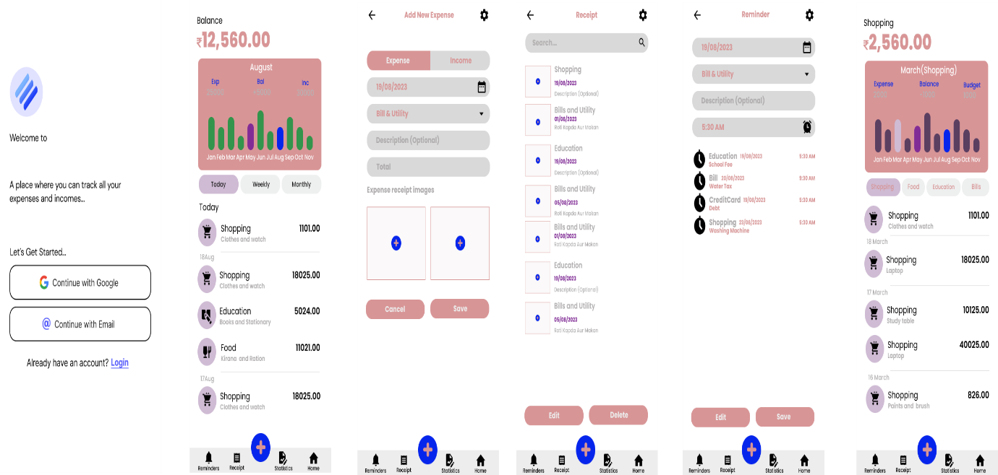

**RESULT:**

The Expense Share App has been successfully developed, allowing users to manage shared expenses effortlessly.

**4. Health and Self-Care Mobile App**

This is a mobile application that provides users with health routines, self-care blogs, video tutorials, and subscription-based wellness content.

**AIM:**

To design a mobile application that promotes health and self-care through blogs, video tutorials, and personalized wellness plans.

**PROCEDURE:**

1. Install the required development tools.
2. Design the user interface with an intuitive layout.
3. Implement user registration and login features.
4. Develop sections for health routine blogs and self-care blogs.
5. Integrate self-care video tutorials for guided wellness practices.
6. Implement subscription features for premium content access.
7. Test, refine, and deploy the application.

**OUTPUT:**

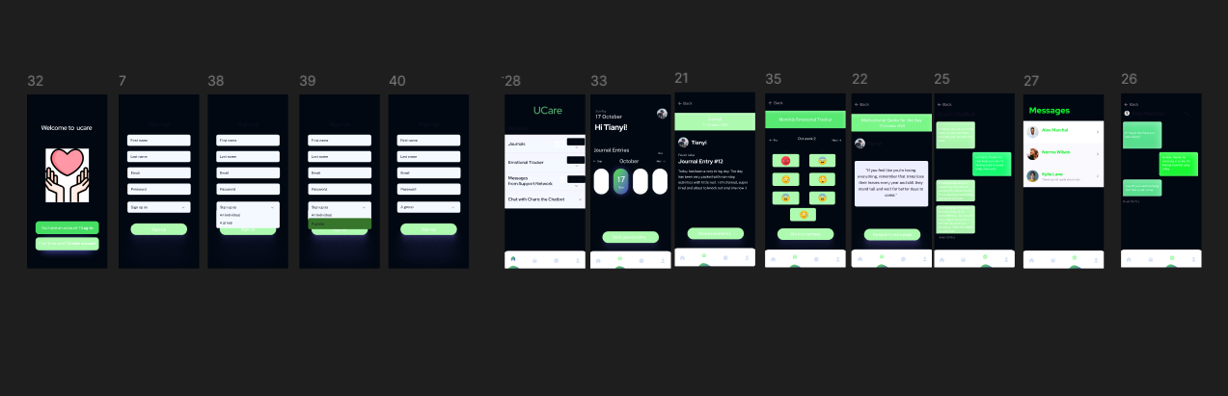

**RESULT:**

The Health and Self-Care App has been successfully developed, enabling users to improve their well-being through structured content and guidance.

Top of Form

**Bottom of Form**

**5. Job Assisting Mobile App**  
 This is a mobile application that streamlines the job search process from registration to contract signing.

**AIM:**

To design an intelligent job assisting application that helps users search for jobs, apply efficiently, and manage their job application process.

**PROCEDURE:**

1. Install the required development tools.
2. Design the user interface with an intuitive layout.
3. Implement login, registration, and subscription features.
4. Develop a profile section for users to provide personal details.
5. Enable resume uploading and document management.
6. Integrate a job search and selection feature.
7. Test, refine, and deploy the application.

**OUTPUT:**

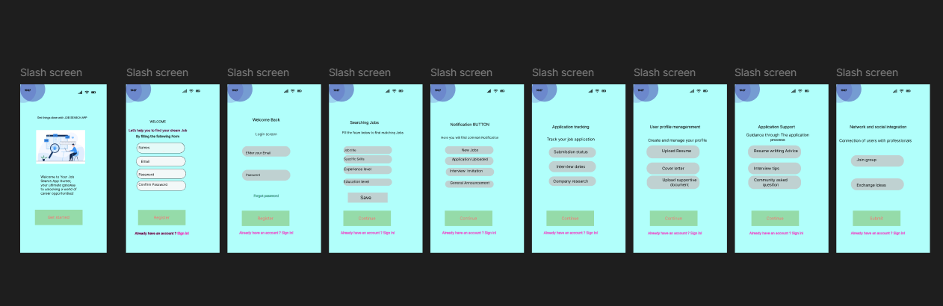

**RESULT:**

The Job Assisting App has been successfully developed, allowing users to navigate the job search process seamlessly.

**6. Parking Slot Booking Mobile App** This is a mobile application that helps users find and book parking slots in unfamiliar areas.

**AIM:**

To design a mobile application that enables users to locate, book, and manage parking slots efficiently.

**PROCEDURE:**

1. Install the required development tools.
2. Design the user interface with an intuitive layout.
3. Implement user registration and login features.
4. Develop a system to display available parking slot counts.
5. Show free parking slot details with real-time updates.
6. Enable users to book slots and manage reservations.
7. Generate parking-related bills and payment options.

**OUTPUT:**

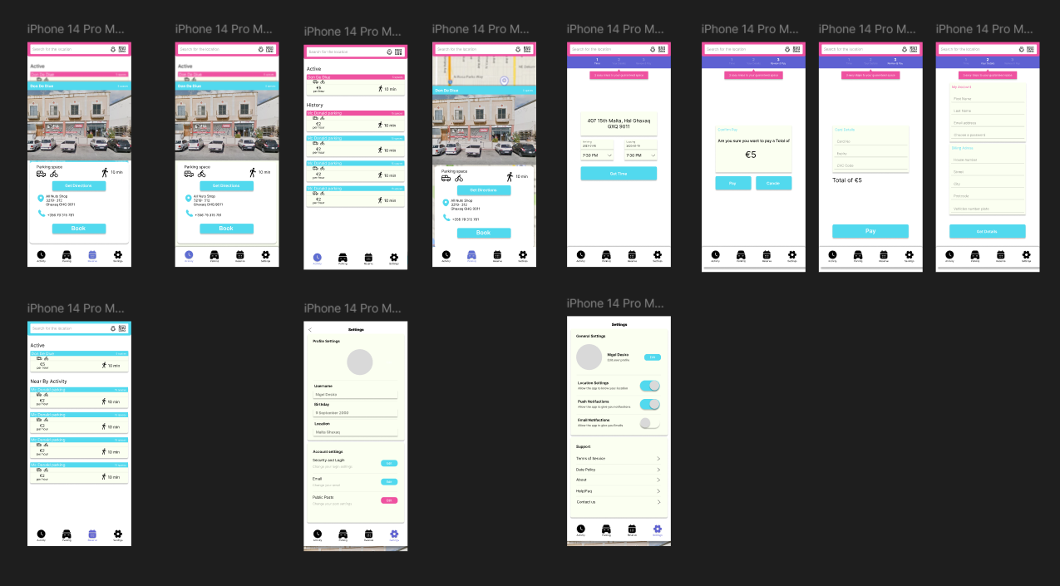

**RESULT:**

The Parking Slot Booking App has been successfully developed, allowing users to find and reserve parking spaces seamlessly.

**7. International Hospitality Services Mobile App**

This is a mobile application that helps users find, book, and manage stays at international hospitality services.

**AIM:**

To design a mobile application that enables users to explore, book, and manage international hospitality services seamlessly.

**PROCEDURE:**

1. Install the required development tools.
2. Design the user interface with an intuitive layout.
3. Implement user registration and login features.
4. Display available stays with discounted offers.
5. Enable users to book stays for specific dates.
6. Generate billing and payment options.
7. Test, refine, and deploy the application.

**OUTPUT:**

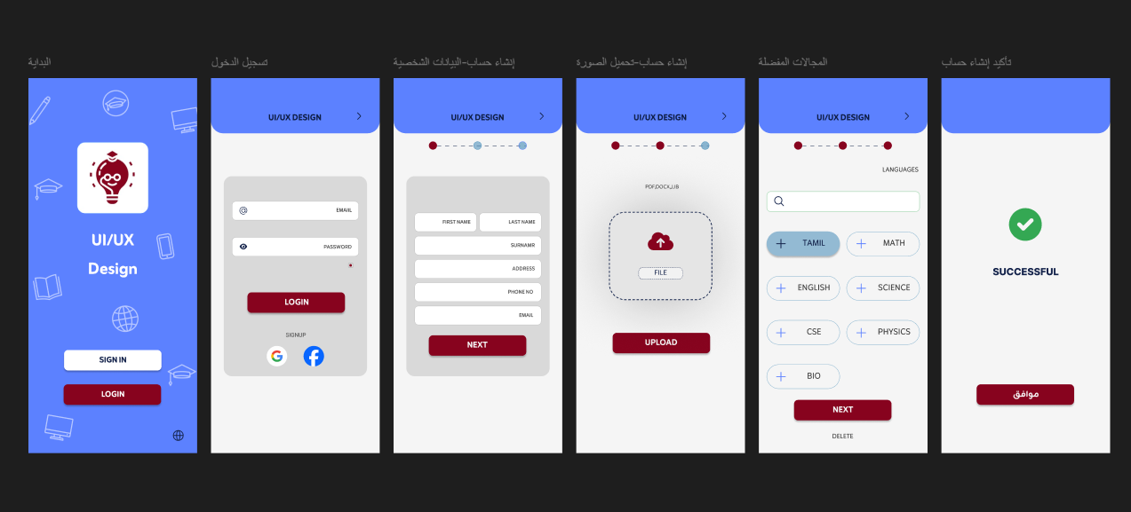

**RESULT:**

The International Hospitality Services App has been successfully developed, allowing users to book discounted stays with ease.

**8.Food Recipe Mobile App Prototype**  
 This is a mobile application prototype that enables users to authenticate, select cuisines, watch recipe tutorials, and upload their own recipes.

**AIM:**

To design and develop a prototype for a food recipe mobile application with user authentication, location-based cuisine selection, video tutorials, and user-generated content.

**PROCEDURE:**

1. Install the required development tools (Figma, Flutter, or React Native).
2. Design the user interface, including login, registration, and navigation screens.
3. Implement user authentication for secure login and registration.
4. Develop a feature for users to select preferred location and cuisine.
5. Integrate recipe video tutorials for enhanced learning.
6. Enable users to upload and manage their own recipes.
7. Test the prototype for usability and functionality.

**OUTPUT:**

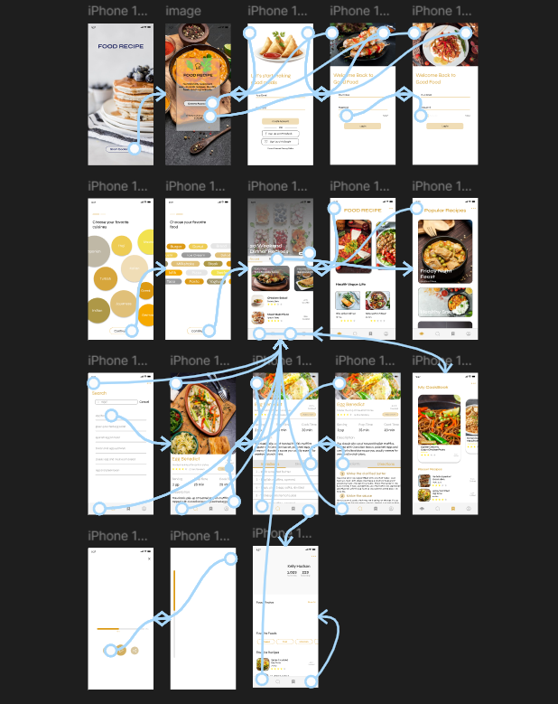

**RESULT:**

The Food Recipe Mobile App prototype has been successfully developed, demonstrating essential features for user interaction.

**9. Community Chatting App**

This is a mobile application that allows friends to connect through chats, calls, and group interactions.

**AIM:**

To design and develop a chatting app that enables user communication through messaging, calls, and group interactions.

**PROCEDURE:**

1. Install the required development tools.
2. Design the user interface with an intuitive chat layout.
3. Implement user registration and login features.
4. Develop status update and friend-adding functionalities.
5. Enable group creation and individual/group chats.
6. Integrate video/audio calling features.
7. Test, refine, and deploy the application.

**OUTPUT:**

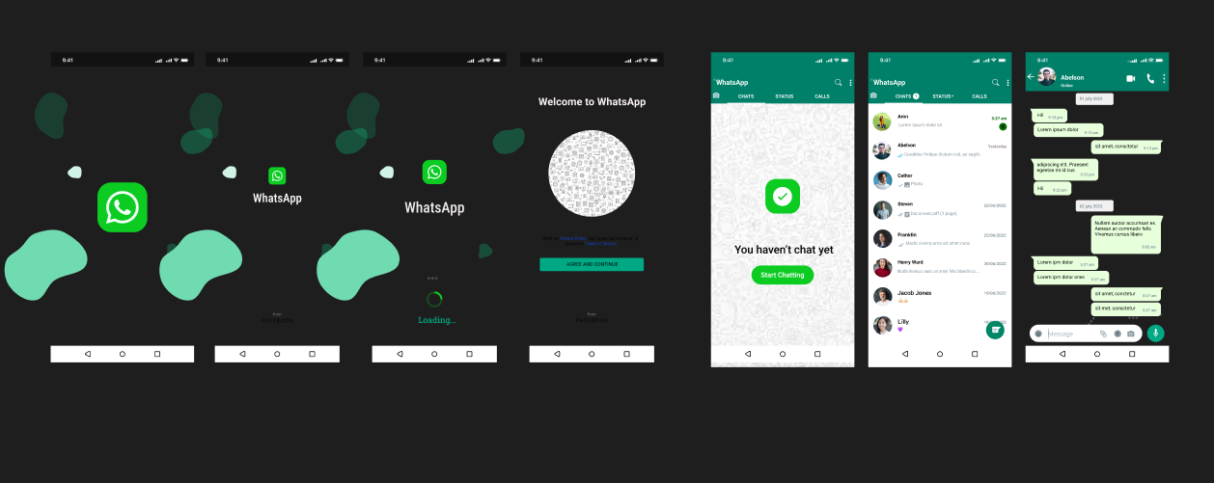

**RESULT:**

The Community Chatting App has been successfully developed, allowing friends to communicate seamlessly.

**10. Movie Ticket Booking App**  
 This is a mobile application that enables users to book movie tickets online with seat selection and payment options.

**AIM:**

To design and develop a movie ticket booking application with user authentication, movie selection, seat reservation, and online payment functionalities.

**PROCEDURE:**

1. Install the required development tools.
2. Design the user interface with an intuitive booking layout.
3. Implement user registration and login features.
4. Develop a movie selection and showtime browsing feature.
5. Enable seat reservation with real-time availability updates.
6. Integrate secure online payment options.
7. Test, refine, and deploy the application.

**OUTPUT:**

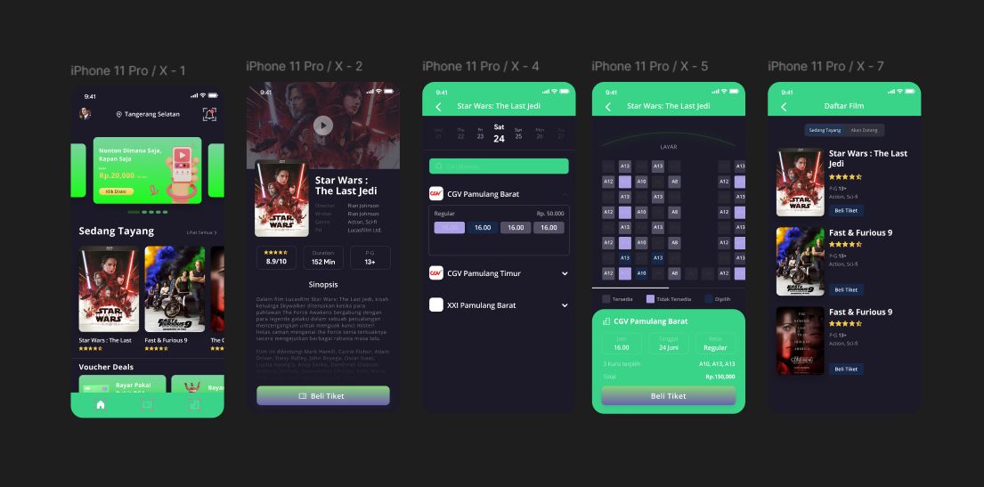

**RESULT:**

The Movie Ticket Booking App has been successfully developed, allowing users to book tickets seamlessly.

11. Food Ordering Mobile App

This is a mobile application that allows users to order food online with real-time tracking and payment options.

**AIM:**

To design and develop a food ordering mobile application with user authentication, cuisine selection, order placement, discount calculation, online payment, and live tracking.

**PROCEDURE:**

1. Install the required development tools.
2. Design the user interface with an intuitive ordering layout.
3. Implement user registration and login features.
4. Develop a cuisine selection and menu browsing feature.
5. Enable food order placement and discount calculation.
6. Integrate secure online payment options.
7. Implement real-time order tracking using a live map.

**OUTPUT:**

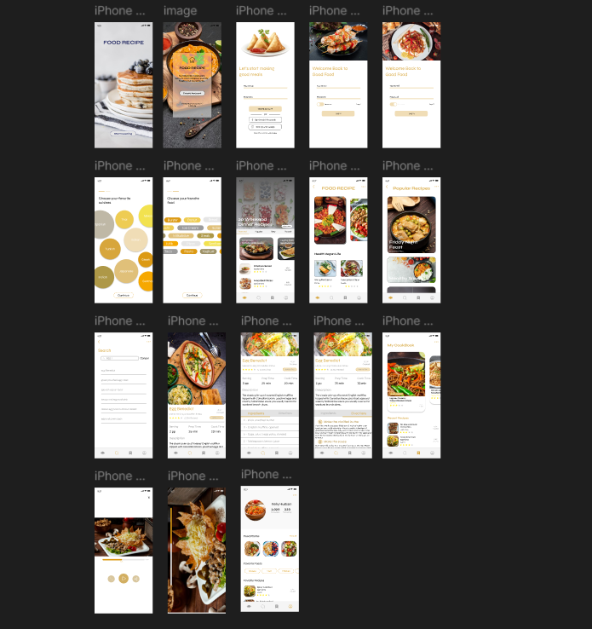

**RESULT:**

The Food Ordering Mobile App has been successfully developed, allowing users to order and track their meals effortlessly.

**12. Cab Booking App**

This is a mobile application that allows users to book cabs with real-time tracking and online payment options.

**AIM:**

To design and develop a cab booking application with user authentication, location selection, discount calculation, online payment, and live tracking.

**PROCEDURE:**

1. Install the required development tools.
2. Design the user interface with an intuitive booking layout.
3. Implement user registration and login features.
4. Develop pickup and drop location selection functionality.
5. Enable fare estimation and discount calculation.
6. Integrate secure online payment options.
7. Implement real-time cab tracking using a live map.

**OUTPUT:**

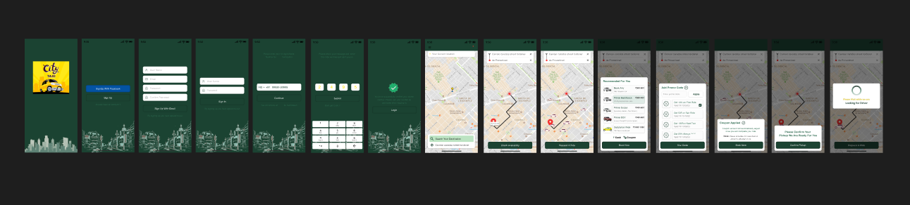

**RESULT:**

The Cab Booking App has been successfully developed, allowing users to book and track rides effortlessly.

**13. Grocery Ordering App**

This is a mobile application that enables users to order groceries online with real-time tracking and secure payment options.

**AIM:**

To design and develop a grocery ordering application with user authentication, grocery selection, order placement, online payment, and live tracking.

**PROCEDURE:**

1. Install the required development tools.
2. Design the user interface with an intuitive shopping layout.
3. Implement user registration and login features.
4. Develop a grocery browsing and selection feature.
5. Enable order placement and secure online payment.
6. Integrate real-time order tracking with a live map.
7. Test, refine, and deploy the application.

**OUTPUT:**

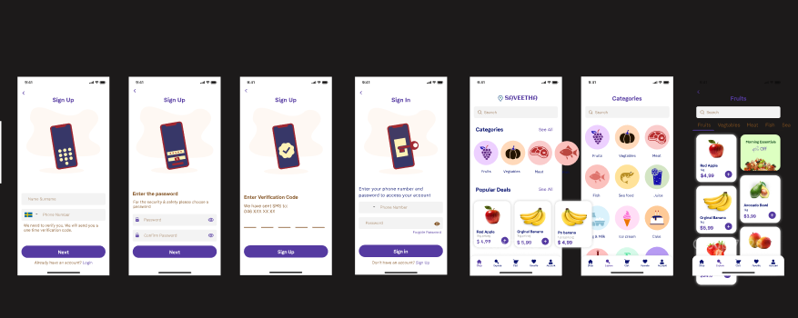

**RESULT:**

The Grocery Ordering App has been successfully developed, allowing users to order and track groceries in real-time.

**14. News Publication App**  
 This is a mobile application that provides users with personalized news content, newspaper access, and subscription options.

**AIM:**

To design and develop a news publication app with user authentication, personalized news updates, newspaper access, and subscription features.

**PROCEDURE:**

1. Install the required development tools.
2. Design the user interface with an intuitive news layout.
3. Implement user registration and login features.
4. Develop a section for news shorts and quick updates.
5. Display various newspapers for user selection.
6. Integrate online payment for subscriptions.
7. Test, refine, and deploy the application.

**OUTPUT:**

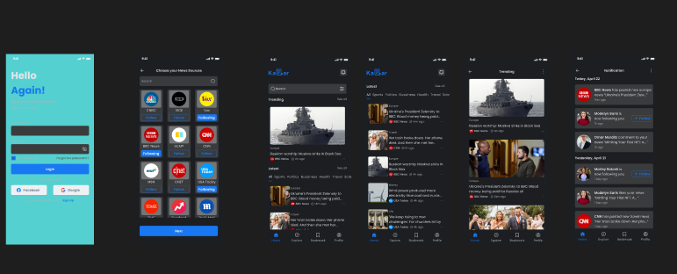

**RESULT:**

The News Publication App has been successfully developed, allowing users to access and subscribe to news content seamlessly.

**15. News Publication Video Surfing App**

This is a mobile application that allows users to surf news-related videos with free and premium membership options.

**AIM:**

To design and develop a news video surfing application with user authentication, content discovery, contribution, and membership options.

**PROCEDURE:**

1. Install the required development tools.
2. Design the user interface with an intuitive video browsing layout.
3. Implement user authentication for login and registration.
4. Develop content discovery features for trending and personalized news videos.
5. Enable users to contribute their own news videos.
6. Implement membership tiers for regular and premium users.
7. Integrate online payment for premium subscriptions.

**OUTPUT:**

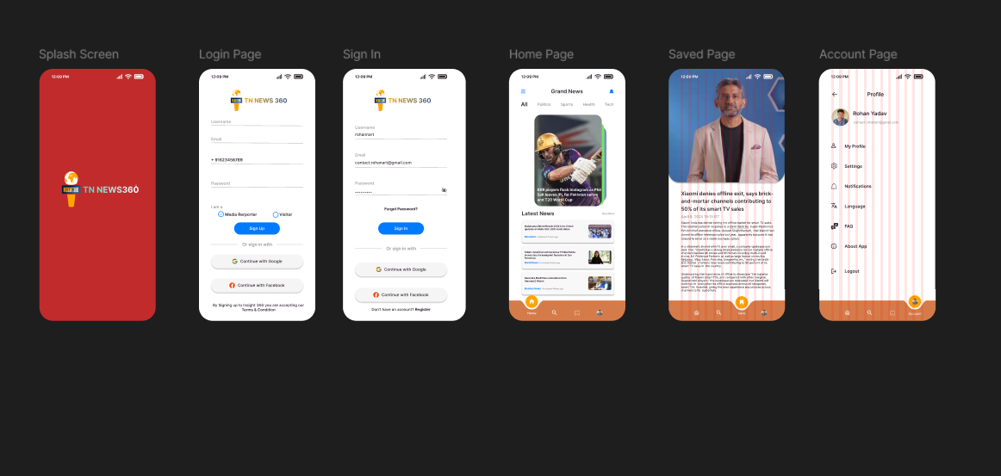

**RESULT:**

The News Publication Video Surfing App has been successfully developed, allowing users to explore and contribute news videos seamlessly.

**16. Flight Ticket Booking App**

This is a mobile application that enables users to search, book, and generate tickets for local and international flights.

**AIM:**

To design and develop a flight ticket booking application with user authentication, flight search, booking, and ticket generation functionalities.

**PROCEDURE:**

1. Install the required development tools.
2. Design the user interface with an intuitive booking layout.
3. Implement user registration and login features.
4. Develop a pickup and drop location selection feature.
5. Display available flight options based on user preferences.
6. Enable seamless booking and payment processing.
7. Generate e-tickets for successful bookings.

**OUTPUT:**



**RESULT:**

The Flight Ticket Booking App has been successfully developed, allowing users to book flights effortlessly.

**17. Online Shopping App**

This is a mobile application that enables users to browse, select, and order products with an integrated billing system.

**AIM:**

To design and develop an online shopping application with user authentication, product browsing, ordering, and bill generation functionalities.

**PROCEDURE:**

1. Install the required development tools.
2. Design the user interface with an intuitive shopping layout.
3. Implement user registration and login features.
4. Develop a product display and selection feature.
5. Enable seamless order placement with cart management.
6. Integrate secure online payment options.
7. Generate bills for successful purchases.

**OUTPUT:**

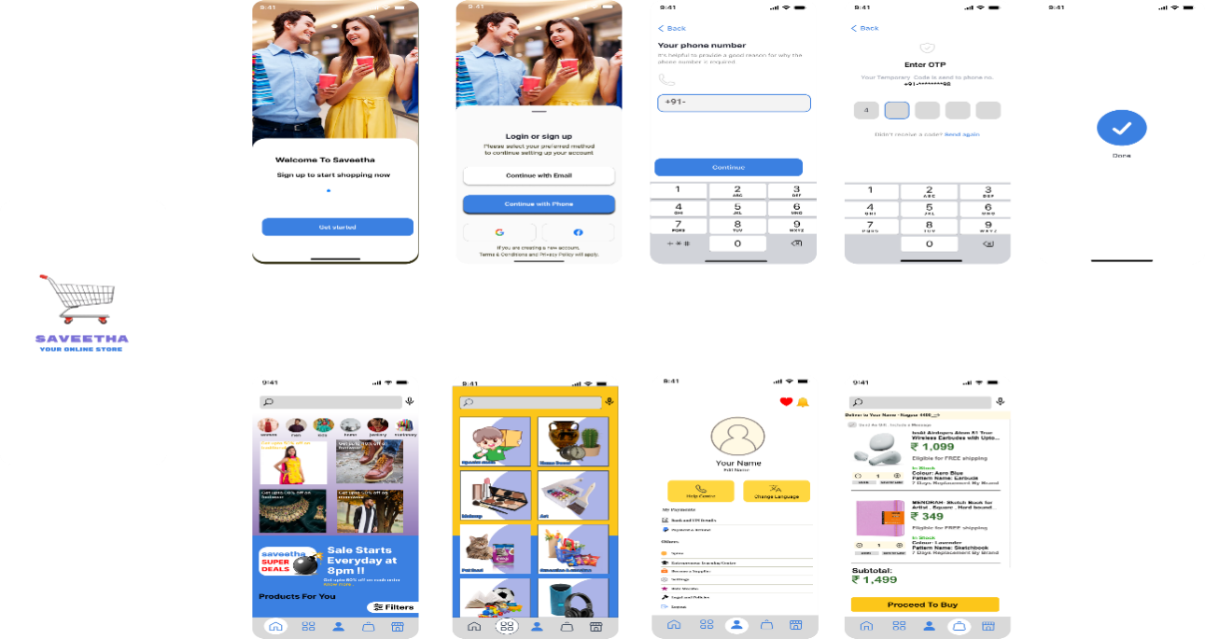

**RESULT:**

The Online Shopping App has been successfully developed, allowing users to shop seamlessly.Top of Form

**Bottom of Form**

**18. Hostel Reservation App**

This is a mobile application that enables users to book hostels and hotels online with seamless reservation and billing features.

**AIM:**

To design and develop a hostel reservation application with user authentication, location selection, hotel listings, and a booking system.

**PROCEDURE:**

1. Install the required development tools.
2. Design the user interface with an intuitive booking layout.
3. Implement user registration and login features.
4. Develop a location-based search for available hostels and hotels.
5. Enable date selection and display hotel listings.
6. Implement the booking and payment process.
7. Generate bills for successful reservations.

**OUTPUT:**

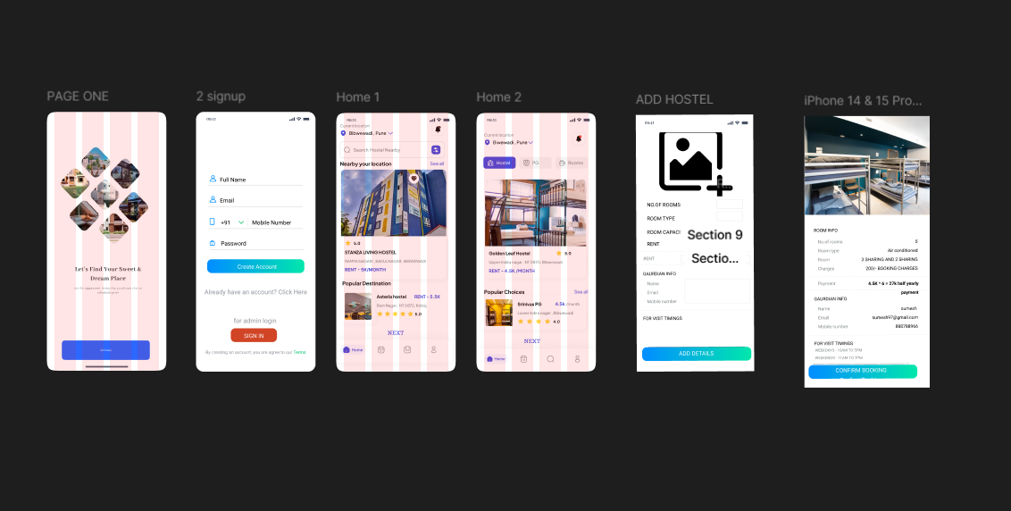

**RESULT:**

The Hostel Reservation App has been successfully developed, allowing users to book accommodations effortlessly.

**19. Online Mobile Recharge App**

This is a mobile application that enables users to recharge their mobile numbers with various top-up and data plans securely.

**AIM:**

To design and develop an online mobile recharge application with user authentication, plan selection, group top-up, and secure payment processing.

**PROCEDURE:**

1. Install the required development tools.
2. Design the user interface with an intuitive recharge layout.
3. Implement user registration and login features.
4. Develop a feature to view and select top-up and data plans.
5. Enable a group top-up option for multiple numbers.
6. Integrate multiple payment options for user convenience.
7. Implement a secure payment gateway for transaction processing.

**OUTPUT:**



**RESULT:**

The Online Mobile Recharge App has been successfully developed, allowing users to recharge their mobiles effortlessly.

**20. Online Music Surfing App**  
 This is a mobile application that enables users to explore, create playlists, and download music with subscription options.

**AIM:**

To design and develop an online music surfing application with user authentication, playlist creation, music downloads, and secure payment integration.

**PROCEDURE:**

1. Install the required development tools.
2. Design the user interface with an intuitive music browsing layout.
3. Implement user registration and login features.
4. Develop a feature to explore and add music to playlists.
5. Enable users to download music for offline access.
6. Integrate a subscription model for premium features.
7. Implement a secure payment gateway for transactions.

**OUTPUT:**

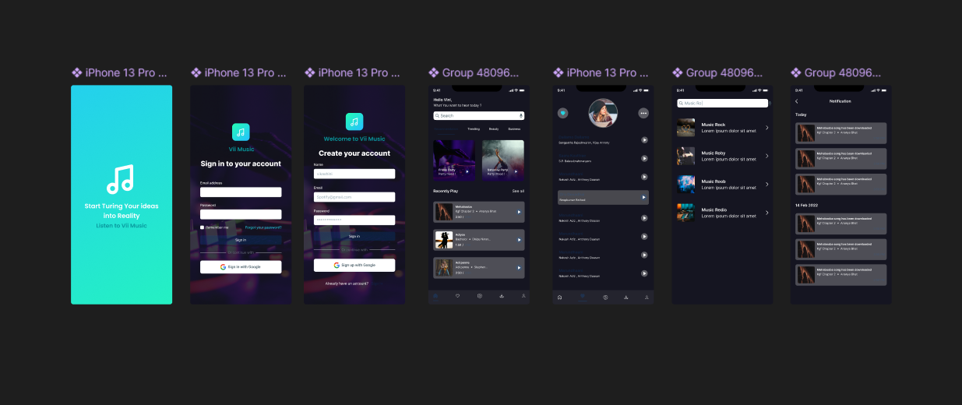

**RESULT:**

The Online Music Surfing App has been successfully developed, allowing users to explore and enjoy music seamlessly.